

**Enterprise Participation and Sponsorship Program for**

**the 35th International Conference and the 1st Asia Conference on Thermoelectrics**

**Introduction of ICT Conference**

**The international conference on thermoelectrics is dedicated to providing an international academic exchange platform for researchers in the field of thermoelectric materials, devices and applications, while providing a stage for enterprises to display their products and ideas. The first ICT Conference was held in September 1, 1976 in Arlington, Texas in the United State. At that time, the conference was held once every 2 years at the same place. From 1989 onwards, the conference schedule was changed to once a year, held routinely by a country of North America, Europe and Asia (including Oceania) in a rotation turns. The conference has been held for 34 times till now. The 35th International and the 1st Asia Conference on Thermoelectrics will be held from May 29 (Sunday) to June 2 (Thursday)** **, 2016 in Wuhan, P. R. China.**

**Review of Last ICT**

**The 34th International Conference on Thermoelectrics was held in Dresden, Germany from June 29 to July 4, 2015. The number of participants was 754, and there were about 30 companies attending this conference as sponsors and exhibitors.**

**Who Are the Participants?**

**Participants of the conference include experts, scholars, students and also enterprise representatives in the field of basic theories, materials, devices, systems and applications on thermoelectrics and related technologies. Conference attendees come from international famous academic institutions, including world famous universities like: Massachusetts Institute of Technology, California Institute of Technology, University of Michigan, Northwestern University, Harvard University, University of Washington, University of California at Berkeley, University of Stuttgart, Freiburg University, the University of Oxford, University of London, Cardiff University, Tohoku University, Osaka University, Nagoya University and etc., and world famous research institutes like: the Oak Ridge National Laboratory, Brookhaven National Laboratory, National Institute of Standards and Technology in the United States, Max Planck Institute (MPI), the German Aerospace Research Establishment (DLR), Fraunhofer Institute for Physical Measurement Techniques (IPM) in Germany and National Institute of Advanced Industrial Science and Technology (AIST) from Japan and other famous research institutions. Domestic participants come from famous universities like Tsinghua University, Zhejiang University, Fudan University, University of Science and Technology of China, Beihang University, Tongji University, Wuhan University, Huazhong University of Science and Technology, Jilin University, Shandong University, and the key research institutes from the Chinese Academy of Sciences (CAS), like Shanghai Institute of ceramics, Institute of physics in Beijing, Institute of physical and chemical technology in Dalian, Institute of material structure in Fujian, etc. Enterprise representatives come mostly from thermoelectric module and device manufactures, such as Marlow Industries Inc., Alphabet Energy, Inc., Gentherm Inc., Thermonamic Electronics (Jiangxi) Corp., FUXIN Group (Guangdong), etc.**

**Conference information:**

**Date:** May 29 (Sunday) to June 2 (Thursday), 2016

**Venue:** Wanda Reign Hotel (The best hotel in central area of P. R. China)

138 Donghu Rd, Wuchang District

Wuhan, Hubei P. R. China

**Organizer:** Wuhan University of Technology

**Co-organizer:** Shanghai Institute of Ceramics, the Chinese Academy of Sciences,

Zhejiang University and Tsinghua University

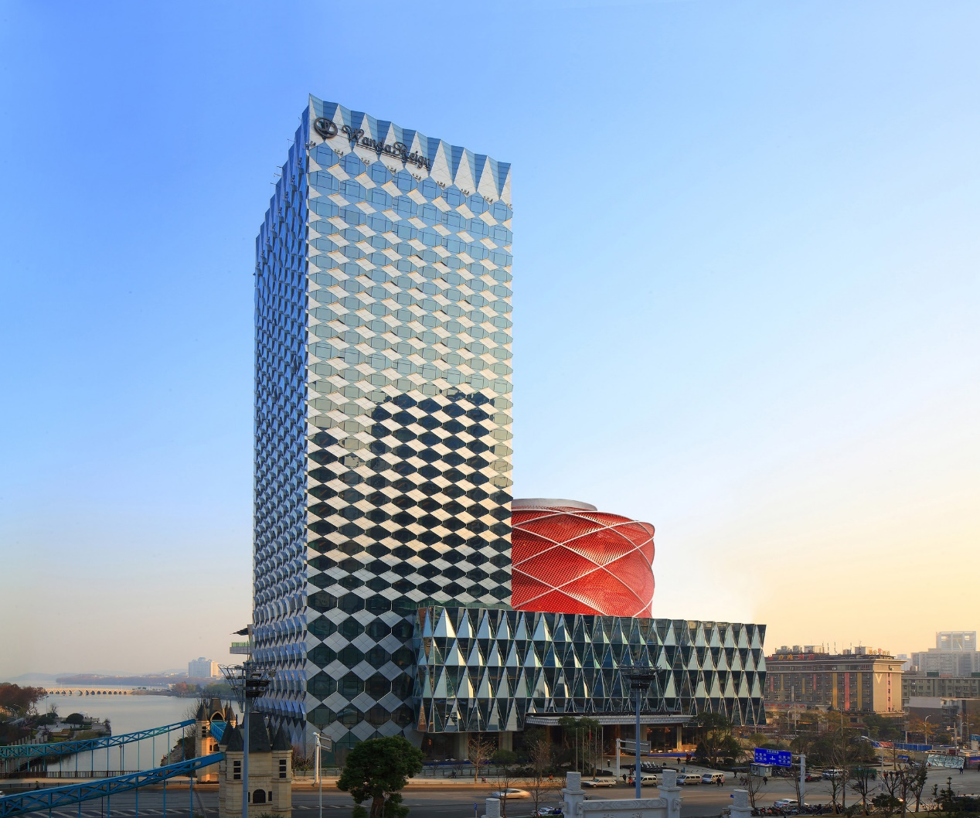

**Exhibition and Sponsorship Information**

**Your organization could support the ICT/ACT 2016 as a gold, silver sponsor or advertisement exhibitor based on the total amount of purchased items and benefits.**

|  |  |  |
| --- | --- | --- |
| **Type** | **Provided items and benefits** | **Payment** |
| **Advertisement**  **exhibitor** | **1. A standard 3x2 m2 exhibition area including one desk, two chairs, power supply and lighting;**  **2. Including registration fee for 2 persons.** | **Domestic: 25,000 RMB**  **Overseas: 4,000 USD** |
| **Silver sponsor** | **1. A standard 3×2 m2 exhibition area including one desk, two chairs, power supply and lighting;**  **2. Including registration fee for 2 persons.**  **3. Advertisement on Final Program Book(including abstracts)(A4, one full color page);**  **4. Insert advertisement in official bag (A4, one full color page).** | **Domestic: 50,000 RMB**  **Overseas: 8,000 USD** |
| **Gold sponsor** | **1. A standard 3×2 m2 exhibition area including one desk, two chairs, power supply and lighting;**  **2. Including registration fee for 2 persons.**  **3. Advertisement on Final Program Book(including abstracts)(A4, one full color page);**  **4. Link at conference website main page**  **5. Insert advertisement in official bag (A4, one full color page).** | **Domestic: 10,0000 RMB**  **Overseas: 15,000 USD** |

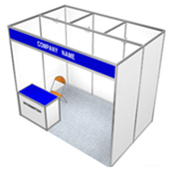**A standard exhibition booth:**

**- 3m x 2m = 6m2**

**- Walls**

**- 1(one) Information desk + 2 (two) folding chairs**

**- 1(one) Wastebasket**

**- Power Outlet AC 220 V 50Hz**

**Exhibition Information**

**■ Schedule**

**- Installation: 14:00 ~ 18:00, May 29 (Sunday), 2016**

**- Exhibition: 08:00 ~ 18:30, May 30 (Monday) ~ June 2 (Thursday), 2016**

**- Removal: 18:30 ~, June 2 (Thursday), 2016**

**■ Venue: the 3rd floor, Wanda Reign Hotel, Wuhan, P. R. China**

**■ How to Apply:**

**■ Layout**

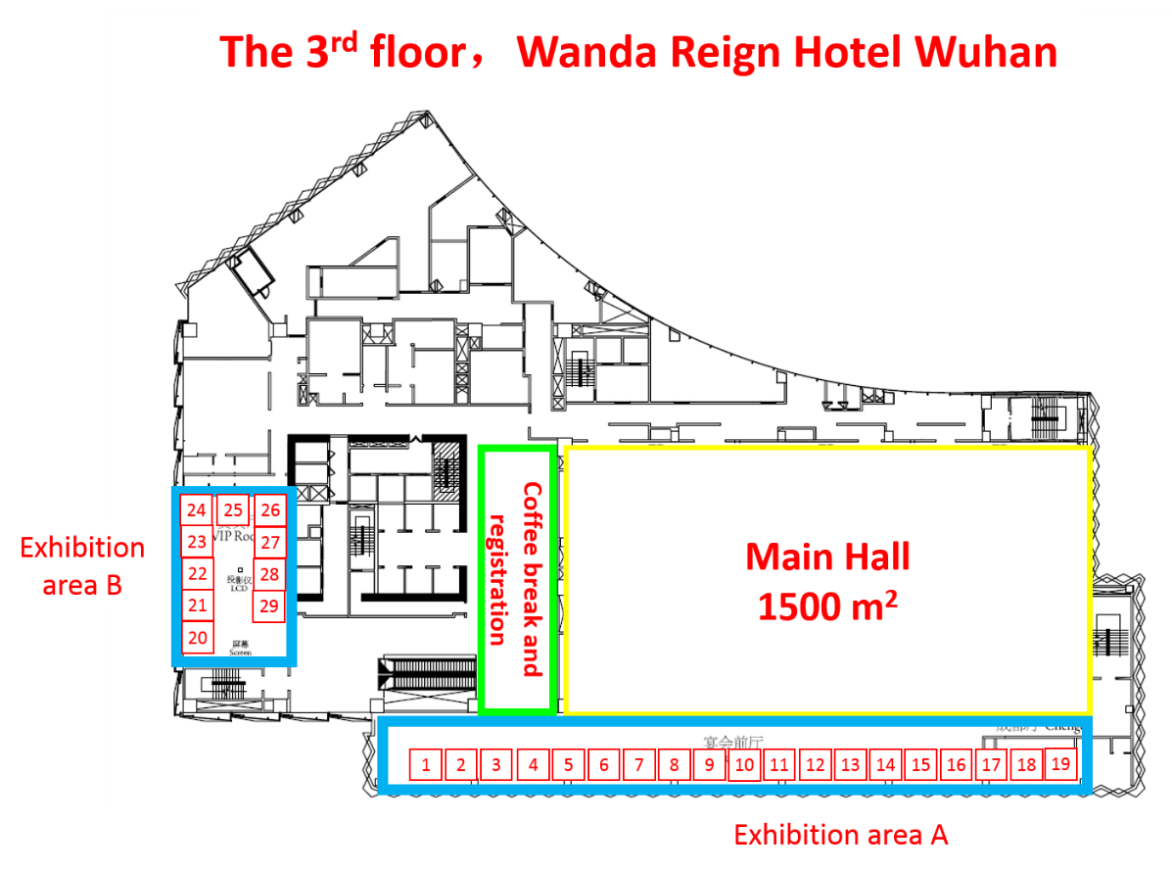

**※ This layout is tentative and subject to change.**

**※ The distribution of the exhibition booth is arranged on a “first come first serve” basis, and is decided by the conference organization committee.**

**Payment & Cancellation Policy**

**To join ICT/ACT 2016 as a sponsor or an exhibitor, please complete the “ICT/ACT 2016 Sponsorship and Exhibition Application Form” on the end of this prospectus and send it to the ICT/ACT 2016 secretariat by e-mail (** [**yanyonggao@whut.edu.cn**](mailto:yanyonggao@whut.edu.cn) **) before Mar. 15, 2016.**

**■ Payment**

**Upon receipt of the signed application form, an invoice covering payment amount will be issued by e-mail or fax. Then the payment should be made in full amount within 1 month of signing the application form before April 15, 2016.**

**■ Cancellation Policy**

**Notification of intent to cancel sponsorship must be provided in writing. This application may be canceled with no penalty, within ten (10) calendar days of receiving the confirmation receipt of the Application Form.**

**- Cancellation of this application before April 30:**

**50% refund excluding the processing fee**

**- Cancellation of this application after April 30: No refunds**

**ICT/ACT 2016 Sponsorship and Exhibition Application Form**

**Please complete this application form and send to ICT/ACT 2016 secretariat (** [**yanyonggao@whut.edu.cn**](mailto:yanyonggao@whut.edu.cn) **) with your company logo.**

|  |  |  |  |
| --- | --- | --- | --- |
| **Company Information** | | | |
| **Company Name** |  | **Contact Person** |  |
| **Department** |  | **Position** |  |
| **Address** |  | | |
| **Tel** |  | **Mobile Phone** |  |
| **Fax** |  | **E-mail** |  |
| **Website** |  | | |
| **Exhibition or Sponsor type** | | | |
| **□ Advertisement exhibitor USD 4,000 □ Silver sponsor USD 8,000**  **□ Gold sponsor USD 15,000** | | | |
| **Payment Details** | | | |
| **Total Amount** |  | **Remark** |  |
| **Expected**  **Remittance Date** |  | **Remitter’s Name** |  |

**※ The payment can only been made by bank transfer and the remitters are responsible for all the bank charges.**

**Bank Account information:**

|  |  |
| --- | --- |
| **Bank Name** | **INDUSTRIAL AND COMMERCIAL BANK OF CHINA HUBEI BRANCH** |
| **Account Number** | **3202006719200487084** |
| **Account Holder** | **WUHAN UNIVERSITY OF TECHNOLOGY** |
| **Swift Code** | **ICBKCNBJHUB** |
| **Bank Address** | **NO. 33, LUOSHI ROAD, WUHAN CHINA** |

**I, or my company, agree(s) on the terms of the ICT/ACT 2016 Sponsorship/ Exhibition Application and apply (applies) for as □ a sponsor/ □ an exhibitor.**

**Date: Signature:**