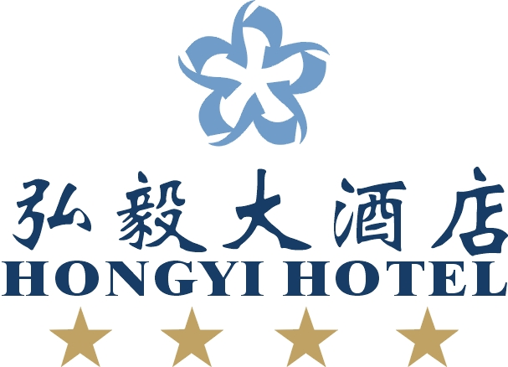
预订确认表

ROOM RESERVATION CONFIRMED BY FAX
2016年武汉理工大学国际热电会议—武汉弘毅酒店订房表格（2016年5月29日 至6月2日）
The 35th International Conference&The 1th Asian Conference On Thermoelectrics
Hongyi Wuhan Hotel -Reservation Reservation Form(May29-June 2,2016)
我们非常高兴确认您如下预订内容：
We are pleased to confirm your reservation as follows:
客人信息/Guest Information

姓名Guest name_______________________ 电话Tel ___________________________

传真Fax ________________________ 国家Country ____________________________

抵店日期Arr. Date______________ 航班Flight _____________ 抵店时间ETA _________________

离店时间Dep. Dat______________ 航班Flight _____________ 抵店时间ETA _________________

客房预订Room Reservation

房间数量No. of Room_______________________
Deluxe King Bed Room/豪华大床房 RMB430 Net Without Breakrast Per Night/每晚430元净价不包含早餐
Business Double Room/豪华双床房 RMB380 Net Without Breakrast Per Night/每晚380元净价不包含早餐
Deluxe Suite Room/豪华套房 RMB888 Net Without Breakrast Per Night/每晚888元净价不包含早餐
The breakfast will be charge at RMB40 per peron 早餐团队优惠价为人民币40元净价。
Please tick your preferred bed type请选择您中意的床型
备注：Remark 预订的房间将保留到抵店当天下午六点前 ，除非已负担保金。
Reservation will be held until 18：00 on check-in date unless guarantee payment is received

护照资料/Passport Details
护照号Passport No _________________签证号VISA No _________________
签发日期及有效期Date of lssue&validity __________________签发地点Place of Issue_________________

信用卡资料/Cregdit Card Details
信用卡号Credit Card No__________________ 有效期 Expired Date_________________________
AMEX VISA Master Card DC 授权签字Authorized Signat___________________

仅供酒店使用Hotel Use Only
预订确认Reservation Confirmed by______________预订确认号Reservation No.________________________

您总共预订____________间 湖景___________________________酒店已为您预订好房间
You booked 1Lake ________________________room, we have receipted your reservation
谢谢您的订房，您若有任何其它需要，请速与我们联系！
Thanks for you information, if you have any request, please don’t hesitate to contact with us.
传真Fax:(86)27-67819889 电邮Email:sales@wdhy-hotel.com
电话Tel:+86-27 67819888 地址：中国湖北武汉武昌东湖路136号 430071

