Application Deadline: May 14, 2007

Signboards and Sign Lettering

Co. Name | (Must be the same as the name entered on the registration form)
Contact |  | Dept./Title
Tel. |  | FAX
E-mail |  | Booth #

Please enter your company’s name below, in English, as it should appear on the signboard:

- The exhibits and signs will be in English, but companies wishing to use both Korean and English in their signboard should enter their company name above in both languages, with the English name in ALL CAPS.

- The lettering will be in blue, using Letter Gothic font against a white background.

- For company names containing special characters or symbols, please be sure to indicate these characters clearly.

- Forms, once received, will not be separately proofread for typographical errors. In the event that corrections must be made after submission, separate processing charges may apply.

<Send the completed forms to:>
Nuri-communication Inc.
2535 BI Center Ste. #603, Gwangryung 2-Ri, Aewol-eup, Jeju-si
Jeju-do, South Korea 695-902 TEL (+82-64-748-1040) FAX (+82-64-746-9317)
Contact: Ms. Youngshin Ryu, E-mail: admin@ict2007.net

Application Deadline: May 14, 2007

Furniture and Misc. Equipment
Co. Name
Contact |  | Dept./Title
Tel. |  | FAX
E-mail

- Each assembled booth will include a desk and one chair free of charge. Add’l equipment from the list below is available for rental
- All furniture and misc. equipment rental fees are for the period of the ICT2007 meeting only (VAT calculated separately)

No. | Item | Spec | Unit Price | Quantity | Amount
CH-1 | Office Chair | 420×420×420 | $ 20  (￦ 20,000)
CH-1 | 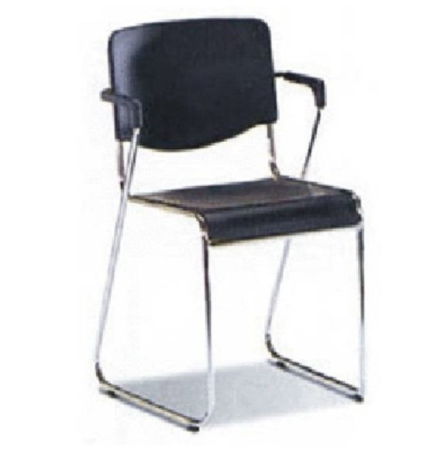
CH-2 | Round-bk Chair | 420×420×420 | $ 15  (￦ 15,000)
CH-2 | 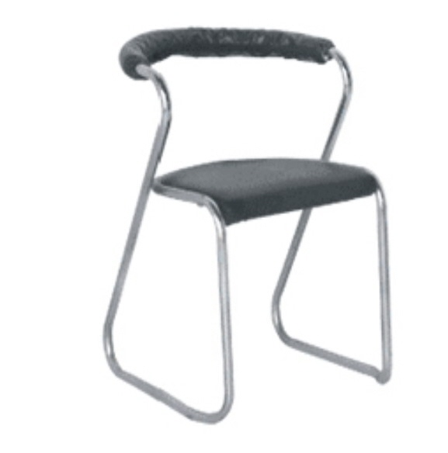
CH-3 | Plastic Chair | 420×420×420 | $ 10  (￦ 10,000)
CH-3 | 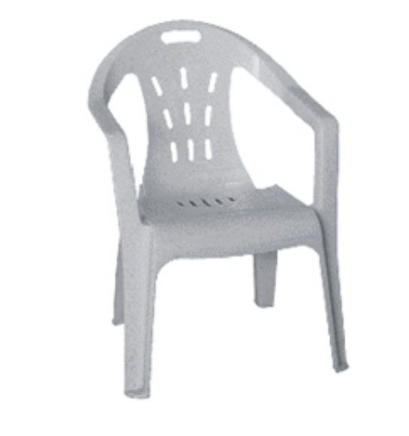
CH-4 | Aluminum Chair | 420×420×420 | $ 25  (￦ 25,000)
CH-4 | 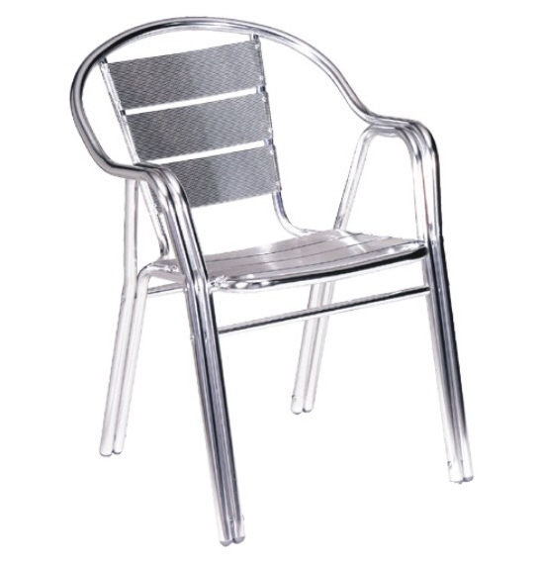
CH-5 | Folding Chair | 420×420×420 | $ 25  (￦ 25,000)
CH-5 | 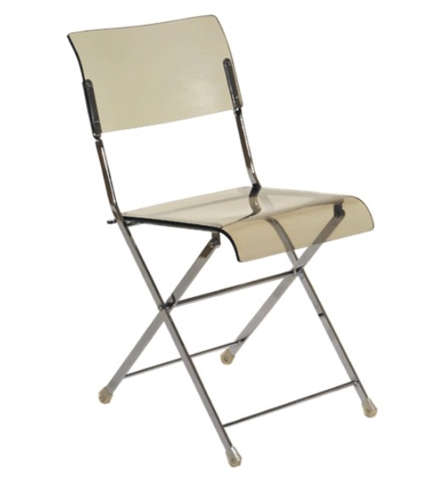
TB-1 | Rect. Table | 1500X750XH750  1800X750XH750 | $ 50  (￦ 50,000)
TB-1 | 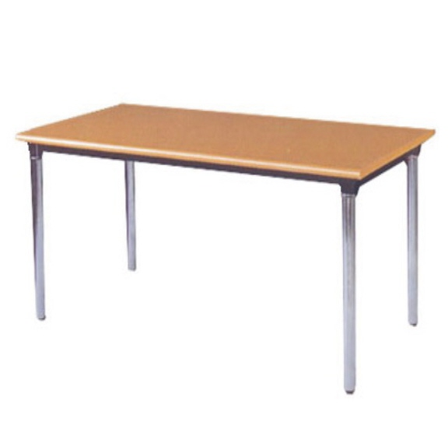
TB-2 | Rd. Table | Ø 900 | $ 65  (￦ 65,000)
TB-2 | 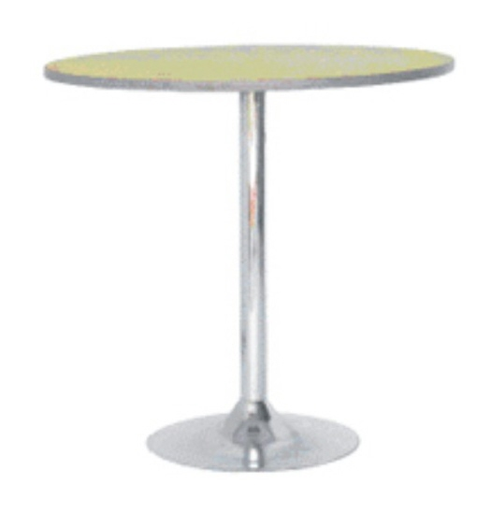
TB-3 | 2-deck display case | 2000X600X750  2000X600X1000 | $ 75  (￦ 75,000)
TB-3 | 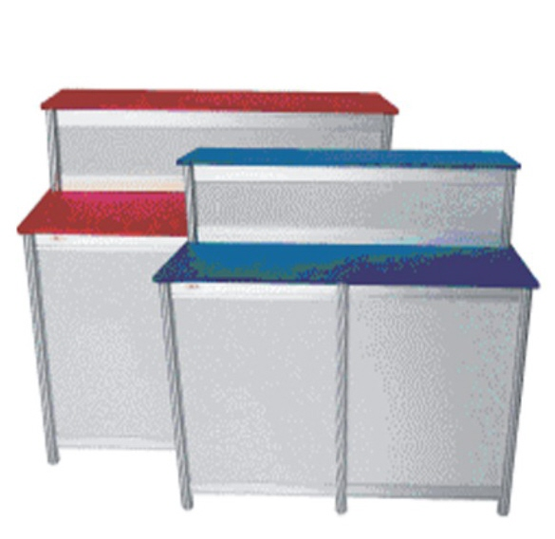
TB-4 | Glass display table | Ø 800 | $ 65  (￦ 65,000)
TB-4 | 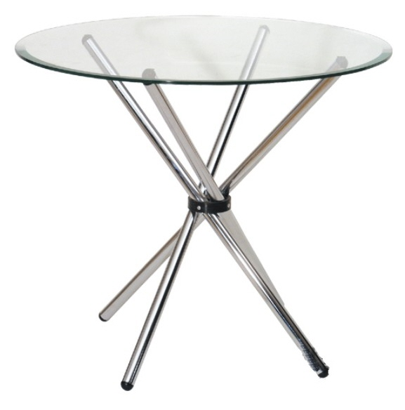
CS-1 | Catalog Stand | 255X310X470 | $ 60  (￦ 60,000)
CS-1 | 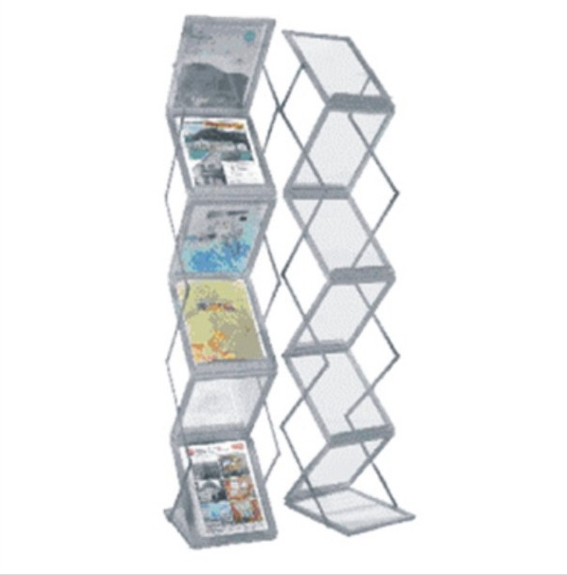

SS-2 | Easel | 500X400X700 | $ 30  (￦ 30,000)
SS-2 | 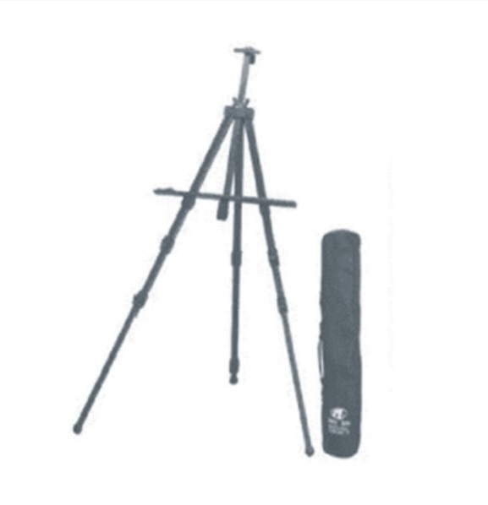
PT1 | LCD Projector | 3600ANSI | $ 450  (￦450,000)
PT1 | 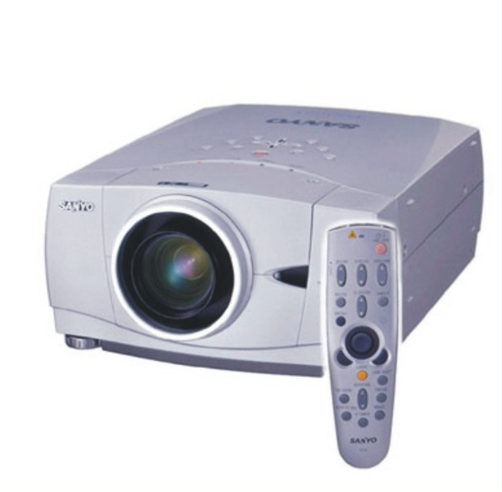
PT2 | LCD Projector+ | 4700ANSI | $ 600  (￦600,000)
PT2 | 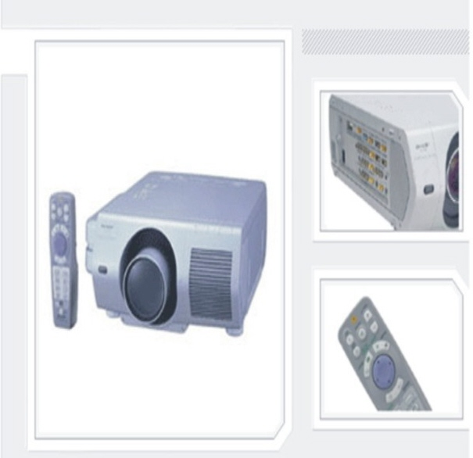
PDP1 | PDP | 42 INCH | $ 470  (￦470,000)
PDP1 | 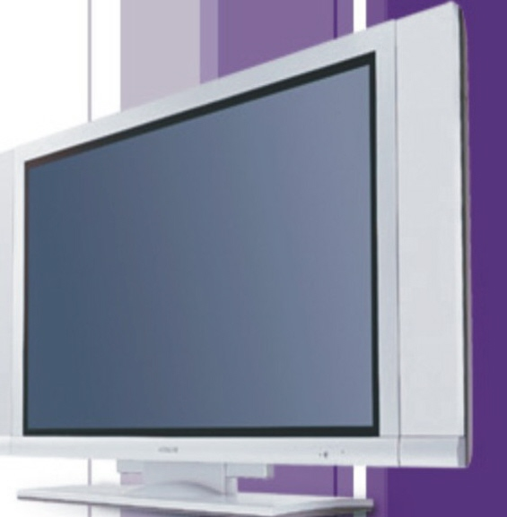
PDP2 | PDP | 50 INCH | $ 630  (￦630,000)
PDP3 | PDP | 63 INCH | $ 800  (￦800,000)
PC | DESK TOP | P4 + 17INCH LCD | $ 170  (￦170,000)
PC | 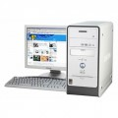
LAPTOP | LAPTOP | P4 | $ 170  (￦170,000)
LAPTOP | 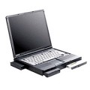
 | SUB-TOTAL
 | V.A.T. (10%)
 | GRAND TOTAL

We cannot guarantee the availability of furniture or equipment for equipment rental applications received after the deadline of May 14, 2007. In cases where requested equipment is not available at the convention center we may be able to make other arrangements for an additional fee.
Rental fees cannot be returned for cancellations made less than 7 days prior to the start of the ICT2007 Meeting.

Equipment Rental Fees should be wired to the bank account to Nuri-communication Inc.
For equipment not on the list above, special inquiries can be made with Nuri-communication Inc.

Payment should be made by wire transfer to:
Bank Name: National Agricultural Cooperative Federation
SWIFT Code: NACFKRSE
Account Number: 901021-55-001021
Account Holder: Nuri-communication Inc.

*Note: When making the wire transfer, please specify the payment as “ICT 2007 F&E”

<Send the completed forms to:>

Nuri-communication Inc.
2535 BI Center Ste. #603, Gwangryung 2-Ri, Aewol-eup, Jeju-si
Jeju-do, South Korea 695-902 TEL (+82-64-748-1040) FAX (+82-64-746-9317)
Contact: Ms. Youngshin Ryu, E-mail: admin@ict2007.net

Points for Exhibitors to Keep in Mind

- Inside the Exhibit Hall
  - Custom booths and equipment must be prepared outside the exhibit hall- within the hall, only booth assembly is permitted (i.e. no arc welding or construction is to be carried out within the exhibit hall!)
  - Exhibitors may not hammer nails into the booth paneling nor may they attach objects using special adhesives such as super glue. In the event that the booth structure or paneling is damaged by such unauthorized tampering, the exhibitor agrees to reimburse the rental provider for any and all repair costs.

- Packaging and Marking of Display Materials/Boxes
  - For exhibitors shipping exhibit materials in advance, please contact Nuri-communication Inc. beforehand. Also, when shipping exhibit materials, please ensure proper packing so that materials are not damaged in transit.
  - All boxed exhibit materials should be marked as follows:

“EXHIBITOR GOODS FOR The 26th ICT 2007”

EXHIBITOR:
PACKAGE NO:
GROSS WT: (㎏) / NET WT: (㎏)
DIMENSIONS: (L)×(W)×(H)㎝

- Disposal and Removal of Exhibit Materials
  - Exhibit materials may not be removed or disposed of without the permission of the conference manager. Exhibitors wishing to remove of or dispose of materials must first obtain a PASS beforehand. (This is to block theft or unauthorized removal of valuable property.) *Removal of exhibit materials permitted after Month:_____ Day:_________
  - Exhibitors are expected to dispose of their own trash. In the event that garbage from booths is left in the exhibit hall, a separate cleanup fee will be assessed.

- Trash Disposal
  - During booth assembly, large or bulky items that will be thrown away should be separately collected by the exhibitor. Regular trash placed in the walkways or hallways will be cleared by the cleaning staff. We also ask that you be sure to separate food waste and general waste, as Korea has a strict recycling policy. Trash mixed with organic waste cannot be processed, so it would be wise for exhibitors to control the amount of food waste they generate. During the period of the conference, the conference management firm will be responsible for keeping walkways and public areas clean; however keeping booths clean is the responsibility of individual exhibitors.
- Security
  - The 26th ICT 2007 Meeting Manager will arrange for 24-hour security during the duration of the conference. However, exhibitors are still responsible for securing their exhibit materials. The conference manager shall take no responsibility for exhibit materials or equipment that is damaged or stolen. It is recommended that exhibitors verify their exhibit materials against an inventory checklist specifying quantity and condition at the time of unpacking and packing.

