Here comes the Title, in Times New Roman, font 14

author ^{1,*}, author ²,…

¹ Department, Institute, address, postal code, city, country
² Department, Institute, address, postal code, city, country
* email of corresponding author:

Abstract text (Times New Roman, font 12). The maximal abstract length, including the references, should be of 1 page. Text justified at both sides.

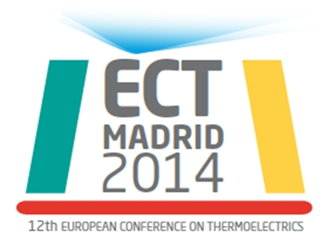

Figure 1: Times New Roman, font 10. Same for the captions of tables, which should be labelled as Table I, Table II, etc.

References:

[1] A. Blaublau…, publication title, journal name, volume (number), pages (year).

