Preparation and Characterization of Bi₂Te₃ Nanowires
Woo Lee, Sung Kyun Lee, Roland Scholz, Kornelius Nielsch, Ulrich Gösele
Max-Planck-Institute of Microstructure Physics, Weinberg 2, D-06120 Halle, Germany
Theoretical predictions have shown a significant higher thermoelectric efficiency (2x to 3x) of low-dimensional thermoelectric materials, such as quantum dots (0-D) or nanowires (1-D), than in bulk materials, due to the enhancement of carrier mobility as well as a lower thermal conductivity.^{[1,2]}
In this presentation we will focus on the development and non-lithographic synthesis of thermoelectric nanowire with a monodisperse diameter D_{P} = 30 to 200 nm (ΔD_{P}/D_{P} ~ 8 %). By electrodeposition from an aqueous electrolyte n-type Bi₂Te₃ has been filled homogeneously into the cylindrical nanochannels of alumina membranes with a thickness up to 100 µm (Figure 1). These nanowire arrays exhibit a 2D-polycrystalline arrangement with a periodic distance of 60 nm to 500 nm.
By optimization of the electrodeposition parameters (such as the solution concentration, pH, and the deposition current density) highly crystalline and stoichiometric Bi₂Te₃ nanowires were obtained. X-ray diffraction (XRD) and high-resolution transmission electron microscopy (HR-TEM) analyses have been performed. The electrochemically grown Bi₂Te₃ nanowires exhibit preferentially a (110)-orientation perpendicular to the nanowire axis, which is the optimal orientation for the thermoelectric properties of Bi₂Te₃ due to the highest electrical conductivity perpendicular to the (110) planes.
Moreover preliminary results will be presented on the fabrication of p-type Sb_{1.7}Bi_{0.3}Te₃ nanowires and thermoelectric membranes with p-/n-junction.
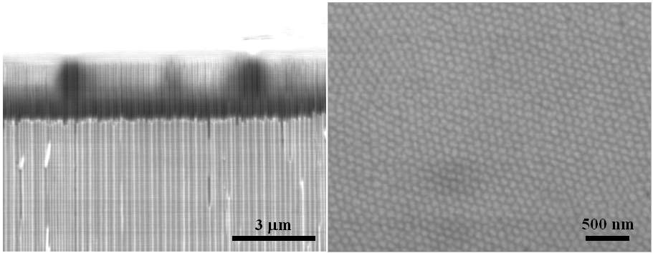

[Fig. 1] SEM images of Bi₂Te₃ nanowires embedded in anodic alumina membrane: cross-section view (a) and top-view (b).

Acknowledgement: This project is supported financially by the German Federal Ministry for Education and Research (BMBF, Project No. 03N8701).

References
[1] L.D. Hicks, T.C. Harman, and M.S. Dresselhaus, Appl. Phys. Lett. 63, 3230 (1993).
[2] T. Koga, T. C. Harman, S. B. Cronin, M. S. Dresselhaus, Phys. Rev. B 60, 14286 (1999).

