PHONON DRAG EFFECT IN Bi MICROWIRES

D.Gitsu¹, T.Huber², L.Konopko¹, A.Nikolaeva¹

¹Institute of Applied. Physics, Academy of Sciences of Moldova, Chisinau, MD-2028, Moldova
²Department of Chemistry, Howard University, 525 College St. N.W. Washington, DC 20059

The temperature dependencies (4.2 – 300 K) of thermopower of thin Bi wires were investigated. The cylindrical Bi crystals ranging in size from 0.1 to 3 μm with glass coating were fabricated by Ulitovsky method. All the samples were similarly oriented: the cylinder axis made an angle of 19.5º with the bisectrix axis in the bisector-trigonal plane.
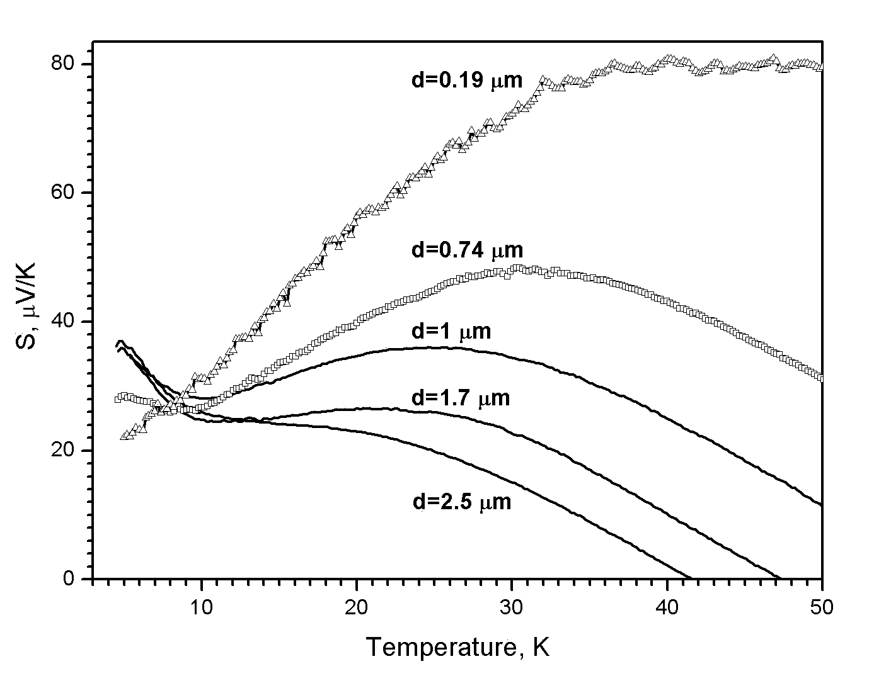
There are two contributions to the thermopower: one connected with diffusion of the carriers and the other with phonon drag [1, 2].
For the first time the phonon drag effect is observed in such low-sized objects like Bi microwires. In figure are shown the temperature dependences of thermopower on Bi microwires with different diameters and approximately equal length l = 3.5 mm. The general behaviour observed for all samples with d ≥ 1 µm is as follows: as the temperature is lowered from 10 K the magnitude of the thermopower increases and achieves its maximum at 5 K. For the sample with d=0.74 µm the phonon drag effect is suppressed and for the sample with d=0.19 µm it is negligibly small. The effect strongly depends on the sample’s length. Thus we are observed considerable decreasing of the phonon drag in the short samples when the length of the samples smaller than 1 mm. In this case only thick samples (d=2.5 and 1.7 µm) have the appreciable positive peak at around 5 K.
The positive thermopower maxima of the order of 10 µVK⁻¹ are explained in terms of the phonon drag of holes. Probable mechanisms of the observed phonon drag effect are discussed.

This work is supported by Civilian Research and Development Foundation for the Independent States of the Former Soviet Union (CRDF) CGP # MO-E1-2603-SI-04

[1] M. Kuznetsov and S. Shalyt, JETP Lett., v. 6, p. 217
[2] C. Uher and W.P. Pratt Jr., J. Phys. F: Metal Phys., v. 8, p. 1979

Corresponding author: Dr. Leonid Konopko
Institute of Applied Physics
Academy of Sciences of Moldova
Academy str. 5
Chisinau, MD-2028 Moldova
Email: konopko@lises.asm.md

